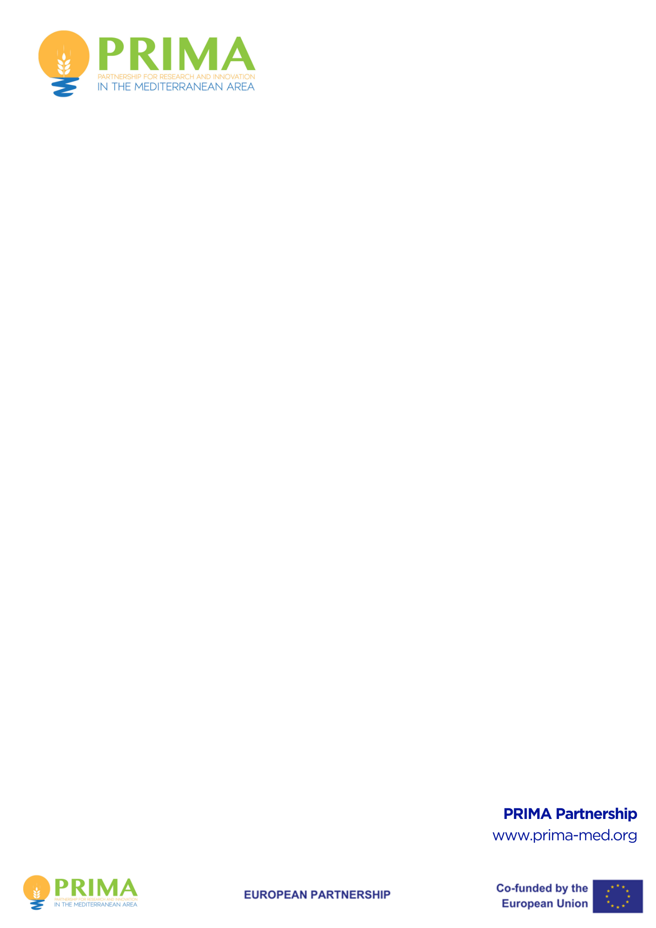

**PRIMA PRIZE FOR**

**WOMAN GREENING FOOD SYSTEMS IN THE MEDITERRANEAN**

**WP2025**

**PRIZE APPLICATION FORM**

(Part II)

# INSTRUCTIONS

(To be removed before submitting)

*Please follow the structure of this template when preparing your application. It has been designed so that the important aspects of your application are presented in a way that allows the experts to make an effective assessment against the evaluation criteria. This application constitutes the written presentation of your achievements.*

*Your response to the award criteria should be precise and concise. An additional section is provided at the end, should you wish to provide any links to publications, articles or projects demonstrating your achievements. This section is non-compulsory.*

*The minimum font size allowed is* ***11*** *points. The page size is A4, and all margins (top, bottom, left, right) should be at least 15 mm (not including any footers or headers).* The application must be written in **English**. *Part II page limit is* ***10 pages****.*

*If you attempt to upload an application longer than the specified limit, you will receive an automatic warning, and will be advised to shorten and re-upload the application.*

Deadline for Submission is: **15 July 2025 at 17:00:00 Central Europe Time**. Make sure to submit Part I and Part II (two PDFs) using the PRIMA Electronic Submission System (ESS). The submission link will be active on the PRIMA official website one month before the mentioned deadline for submission.

**Part II document should be no longer than 10 pages. Once you have completed your application, please delete the cover/instruction page before submitting.**

**Part II – Application Form**

**APPLICATION TITLE:**

**ACRONYM:**

**Lead Contestant - Organisation**

|  |  |
| --- | --- |
| **Participant’s Organisation Name** |  |
| **Participating Organisation - Identification Code (PIC)\*** |  |
| **Country** |  |

**Person in Charge of the Application (Lead Contestant)**

|  |  |
| --- | --- |
| First Name |  |
| Last Name |  |
| E-Mail | *Please indicate your active email for future communication* |
| Position in Organisation | *Please indicate the position of the Contact Point above in the organisation* |
| Nationality |  |

**List of Participants, if any**

|  |  |  |  |  |
| --- | --- | --- | --- | --- |
| **Participant No** | **Name of the Person** | **Country** | **Organisation Name** | **PIC\*** |
| **Partner 1** |  |  |  |  |
| **Partner 2** |  |  |  |  |
| **Partner 3** |  |  |  |  |

*\* PIC: Participant Identification Code (PIC) -* [*https://ec.europa.eu/info/funding-tenders/opportunities/portal/screen/how-to-participate/participant-register-search*](https://ec.europa.eu/info/funding-tenders/opportunities/portal/screen/how-to-participate/participant-register-search)

1. **AWARD CRITERION ONE: Innovative Solutions for Greening Food Systems**

*Explain how a woman, a group of women, or a group led by women have successfully put into action innovative and creative solutions in greening food systems across the Mediterranean region. This involves, but not limited to, pioneering approaches in agriculture, food production, and waste reduction that prioritize environmental sustainability, biodiversity conservation, and resource efficiency.*

1. **AWARD CRITERION TWO: Evidence of Impactful Implementation**

*Explain the clear and tangible results of the applied solutions you've put in place. Show how this(ese) solution(s) has/have made things better in terms of sustainability, environment, economic, resilience, and inclusivity in the food and agriculture sector in the Mediterranean. You should demonstrate the ultimate achieved/expected impact of the solution via quantifiable metrics such as contributes to reductions in carbon emissions, improvements in soil health, increased biodiversity, or enhanced food security and nutrition outcomes, increase in the income of the small farmers, mainly females, etc. Quantify the outcomes and impacts with a set of key performance indicators with values and numbers.*

1. **AWARD CRITERION THREE: Women Empowerment for Green Food Systems**

*Demonstrate how women actively engage and empower the local communities and stakeholders in decision-making processes and project implementation, particularly in greening food systems in the Mediterranean. Show the inclusive participation, and equitable access to resources, opportunities for capacity building, and promoting leadership roles for women and marginalized groups in initiatives aimed at enhancing the sustainability and resilience of food systems. Mention clearly as well the gender dimension of your innovation and how women and young girls – as final beneficiaries and target groups - benefit from the delivered solution. Figures and statistics are encouraged to measure the actual impact of the innovation and the activities in empowering women in greening the food system in the Mediterranean.*

**VIDEO** - non-compulsory section

You are required to support your application with an inspiring video message, up to 90 seconds. Please include a link to the video below:

**Any additional Materials, hyperlinks, publications** - non-compulsory section

**Part II should be no longer than 10 pages. Once you have completed your application, please delete the cover/instruction page before submitting your file as a PDF to the electronic submission system (ESS).**